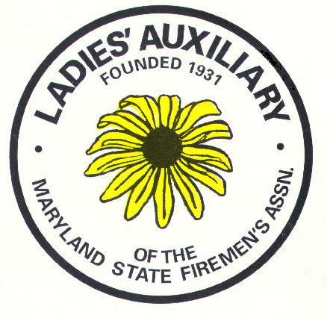

LADIES AUXILIARY

MARYLAND STATE

FIREMEN’S ASSOCIATION

**History Book Registration Form**

**Submission of your Auxiliary history book to be judged for:**

**Presentation**

**Activities**

**Creativity**

**The history book should contain information from January 1st until December 31st of the previous year. The book should be turned in at the LAMSFA President at the Spring Conference with 1st, 2nd and 3rd place being awarded at the Convention in Ocean City.**

**The books will be judged by three Past Presidents selected by the President.**

Date: _______________________________

Auxiliary Name: _________________________________________________

Submitted by: ___________________________________________________

Phone Number: _________________________________________________

**PLEASE PRINT CLEARLY SO CERTIFICATES ARE CORRECT**

Official Auxiliary Name: __________________________________________________

Address: _______________________________________________________________

Phone number: __________________________________________________________

Email contact: __________________________________________________________